Probability and Statistics - IT2120
IT24103297
Lab4

1)

2)
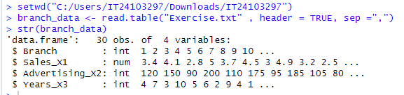
3)
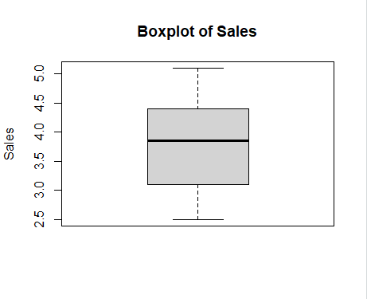
4)
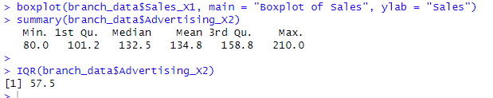
5)
